**Project Design Phase-II**

**Technology Stack (Architecture & Stack)**

|  |  |
| --- | --- |
| Date | 03 October 2022 |
| Team ID | PNT2022TMID37477 |
| Project Name | Smart Fashion Recommender Application |
| Maximum Marks | 4 Marks |

***Technical Architecture:***

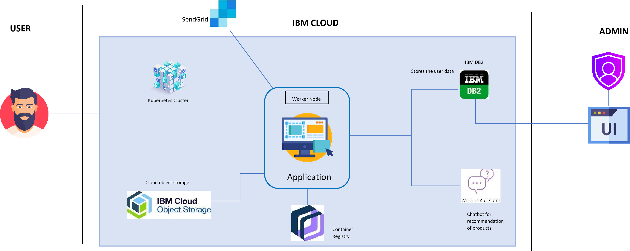

***Table-1: Components & Technologies*:**

|  |  |  |  |
| --- | --- | --- | --- |
| **S. No** | **Component** | **Description** | **Technology** |
| 1. | User Interface | The user interacts with web application e.g., Web UI | HTML, CSS, JavaScript, Flask. |
| 2. | Application Logic-1 | The application includes login where user can login with their credentials and also supports registration where new users can be added. | Python |
| 3. | Application Logic-2 | The application includes a chatbot which helps the user in recommendation of products. | IBM Watson Assistant |
| 4. | Database | Details of customers and products are stored | MySQL |
| 5. | Cloud Database | The cloud database ensures secured storage of data | IBM DB2, IBM Cloudant, etc. |
| 6. | File Storage | File storage requirements | IBM Object Storage or Other Storage Service or Local Filesystem |
| 7. | External API | To send emails from the application | SendGrid |
| 8. | Infrastructure (Server / Cloud) | Application Deployment on Local System / Cloud Local Server Configuration:  Cloud Server Configuration: | Docker, Kubernetes, etc. |

**Table-2: Application Characteristics:**

|  |  |  |  |
| --- | --- | --- | --- |
| **S. No** | **Characteristics** | **Description** | **Technology** |
| 1. | Open-Source Frameworks | Flask is an open-source web framework. The web application is built using Flask | Flask |
| 2. | Security Implementations | * Enable Role-based access control * Enables strict version control and permits rapid rollbacks if a vulnerability is uncovered in new code. | Container registry, Kubernetes |
| 3. | Scalable Architecture | Handles large number users on demand | Container registry, Kubernetes |
| 4. | Availability | The application can be accessed at any time | Docker |
| 5. | Performance | Handles many numbers of user’s requests without ambiguity | Docker |